[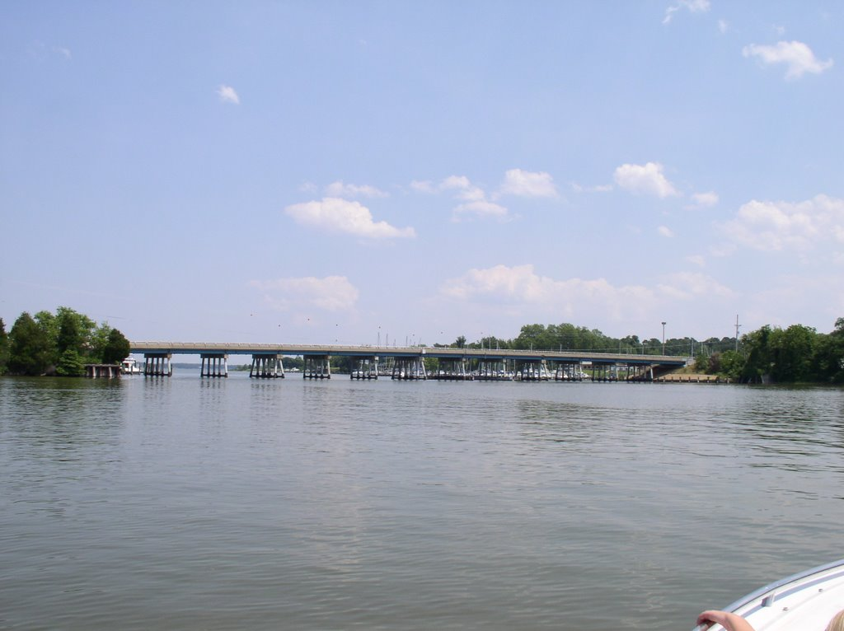](http://www.panoramio.com/photo_explorer#user=1469776&with_photo_id=11882073&order=date_desc)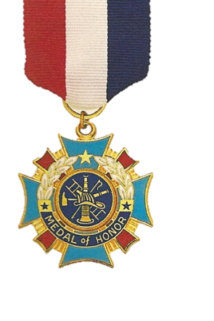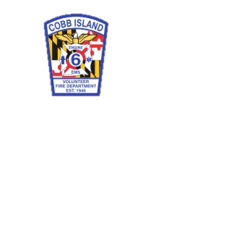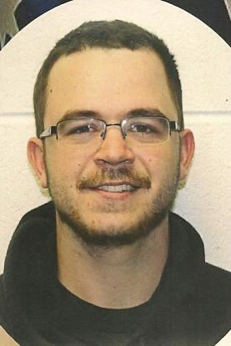

“**Greater love has no one than this…that one lay down his life for his friends.”**

**Cobb Island Bridge Dedication Ceremony**

**17069 Cobb Island Road (at the firehouse)**

**August 9, 2014**

**10:00 a.m.**

**In Honor of**

**Fire Fighter Christopher Allen Staley**